For further information, please contact:

VALERIE RUSSELL
Children’s Services Manager
valerie.russell@actionforchildren.org.uk

Or

SARAH MACLEOD
Registered Manager
sarah.macleod@actionforchildren.org.uk

Hillcrest Residential Unit
41 Goathill Road
Stornoway
Isle of Lewis HS1 2NX

Tel: 01851 700099

Website: www.actionforchildren.org.uk
Facebook: Action for Children – Outer Hebrides

Action for Children helps the most vulnerable children and young people in Scotland break through injustice, deprivation and inequality, so they can achieve their full potential.

Action for Children, whose registered address is at 3 The Boulevard, Ascot Road, Watford WD18 8AG and registered as a charitable company limited by guarantee in England & Wales under number 4764232. Registered charity numbers 1097940/SCO38092.
Confidentiality

Service User’s information is treated as confidential within the project and will only be shared with the knowledge and permission of the service user except when a child or vulnerable person is at risk.

Equality & Diversity

We respect differences in ethnic origin, gender, religion, sexuality, culture and language both as an employer and service provider.

We will endeavour to communicate in people’s first language and will ensure participation of those with disabilities.

Participation

Young people and their families will be included in meetings and reviews about the progress they are making and their views will be sought before any decisions are made.

They will be asked for their views about the service they are receiving.

They will be encouraged to assist in the shaping and developing of the service.

Comments / Complaints

If you have any problems or concerns regarding the service, please speak to a member of staff. Any problems or concerns will be dealt with promptly.
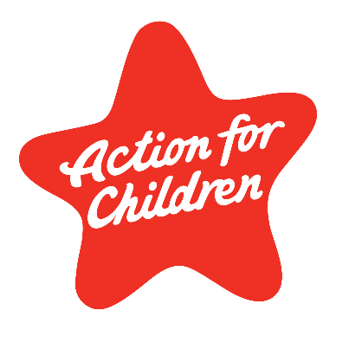

Hillcrest
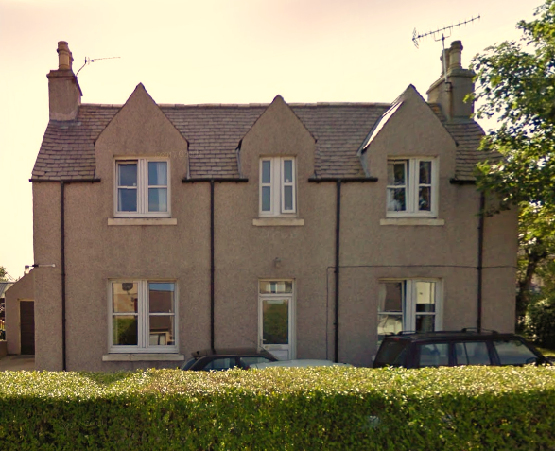
House

A home for young people in the Western Isles -

Who we are…

Hillcrest House is a residential home located on Goathill Road, Stornoway. We house young people for a variety of reasons on both a long and short term basis. We also offer short break respite services for young people with special needs.

We work in partnership with the young people their families and other agencies including Social Work and Health and education Services to ensure that the needs of young people are met.

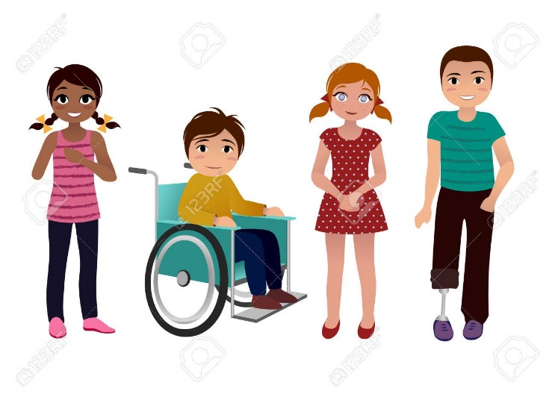
What we provide…

- We offer residences to young people who, for various reasons, need to be accommodated.

- Young people are assessed and individual care plans are drawn up in consultation with them, their families and partner agencies.

- We provide one-to-one support from our childcare workers as well as therapeutic intervention work relevant to a young person’s needs.

- Our service users have access to a wide range of support from various agencies with issues such as advocacy, health and wellbeing and mental health services.

- We offer various extra activities such as sports, arts and crafts and much more.

- Support to young people to improve relationships and participate in community life.

- A safe and caring environment where young people can feel valued.

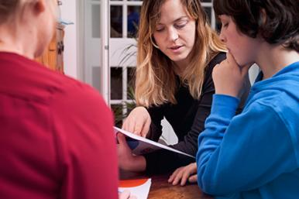

This project is regulated by the Care Inspectorate who can be contacted at: Custom House, Cromwell Quay, Stornoway, Isle of Lewis / 01851 706157

